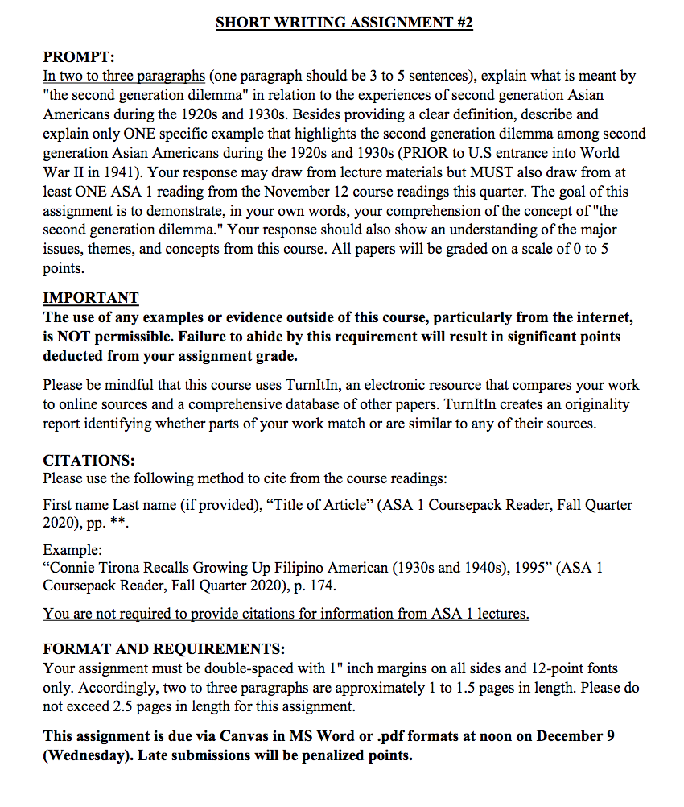

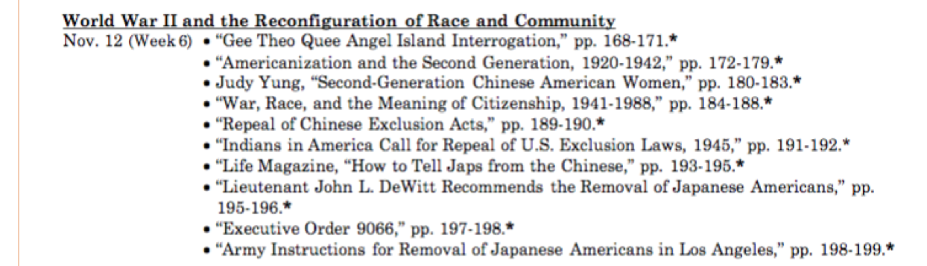

Please see this link for the prompt and instruction!
https://canvas.ucdavis.edu/courses/511303
Then
UCD Login, which is the left one

Then
Username: sfelix
Password: GBumiPermai@F4/2

Then
See Short Writing Assignment 2.pdf in the bottom of the page

You can also able to see the Course Reading Pack and Power Point Slide there, which I think you already know it since you did my Paper#1

Please analyze what do you think about the second generation dilemma in relation to the experience of second generation Asian Americans during 1920-1930. Do not do a summary! The paper is graded based on how students can present their knowledge on this topic and the class material. Does he/she understand the concept well? How he/she address his/her arguments then. Which part of the reading supports his/her arguments? Also, please write it in more specific. Last time YOUR ESSAY ADDRESSES A MORE GENERAL TOPIC THAN THE PROMPT. “THE PAPERS WE ASK YOU TO WRITE MUST HAVE AN ARGUMENT, YOU WERE ESSENTIALLY SUMMARIZING”.

THE GOAL OF THIS ASSIGNMENT IS TO DEMONSTRATE, IN YOUR OWN WORDS, YOUR COMPREHENSION OF THE CONCEPT "THE SECOND GENERATION DILEMMA." YOUR RESPONSE SHOULD ALSO SHOW AN UNDERSTANDING OF THE MAJOT ISSUES, THEME, AND CONCEPTS. "

PLEASE READ THE PROMPT CAREFULLY, ESPECIALLY FOR THE ONE EXAMPLE PART

I HOPE THAT YOU COMPLETE THIS ASSIGNMENT IN LESS THAN 48 HOURS. THANK YOU AND GOOD LUCK!

